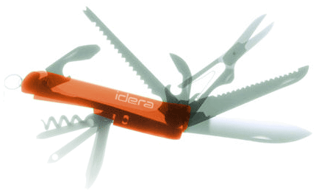

Specification

to

Reduce Logical Reads in Session Batch

Vicky Harp

5/13/09



Proprietary and Confidential to BBS Technologies, Inc.

© 2006 BBS Technologies, Inc.; all rights reserved.

Revision history:
When? | Who? | What?
Vicky | 5/15/2009 | First draft
Vicky | 5/20/2009 | Revised with comments from review

Table of Contents
1. Revision history: ii
2. Table of Contents iii
3. Requirements 1
3.1. Overview/Purpose 1
3.1.1. Related Customer Requests 1
3.2. Target Users 1
3.3. Use Cases 1
3.4. Feature/Function Market Requirements 1
3.4.1. Required Functions 1
3.4.2. Non-Supported Functions 2
3.5. FAQ 2
3.6. Open Issues 2
4. Functional Design 3
4.1. User Interfaces 3
4.2. Installation and Upgrade 3
4.3. Permissions and other Required Configuration 4
4.4. Licensing Issues 4
4.5. Dependencies 4
5. Internal Design 4
5.1. Architecture 4
5.1.1. Collection Service 4
5.1.2. Management Service 5
5.1.3. Desktop Client 5
5.1.4. Repository 5
5.2. Installation Issues 5
5.3. Schedule 5
5.3.1. Work Breakdown and Sizings 5
5.3.2. Areas of Risk 5
6. Quality Assurance Considerations 6
6.1.1. Overview 6
Developer-Created Unit Tests 6
7. Documentation Considerations 6

Requirements

Overview/Purpose
There have been reports of excessive logical reads by the Sessions batch on servers with a high number of sessions (above 10,000 has been reported). In order to reduce the impact of SQLdm’s batches on a monitored server we will be optimizing the Sessions batch.
By way of background: the SQL 2000 batch currently uses DBCC INPUTBUFFER in a loop to populate the Command Text field for the Sessions view. There was some concern that this DBCC was itself causing a high number of logical reads, but upon investigation it appears that the loop structure and use of tempdb is more problematic than the command itself. Therefore this specification will propose changes both to the amount and to the method of data collected.

Related Customer Requests
PR 13957 – Batch performing over 11 million reads on a busy system (over 10K sessions)

Target Users
The most impacted users would be those monitoring servers with thousands of concurrent sessions. Smaller servers will be entirely unaffected.

Use Cases
Change number of DBCC INPUTBUFFER commands executed
- User opens Server Properties panel
- User changes value on General tab
- User clicks OK
- User observes change on Session Details screen, both real-time and history mode

Feature/Function Market Requirements

Required Functions
The number of logical reads caused by the Sessions batch for SQL 2000 must be severely reduced. This will be accomplished through a combination of data reduction and batch optimization. The user must be able to use Server Properties to modify the number of times DBCC INPUTBUFFER will be run, which in turn will control how many statements have Command Text available.
There is no simple formula to describe the number of reads expected based on a given number of batches, but roughly the following can be treated as a guideline:

Number of Sessions | Percent Improvement
< 500 | 75%
500 – 1000 | 80%
1000+ | 90%

Early testing has shown much higher improvements than these numbers, but those tests were under such controlled circumstances that I feel it’s prudent to keep the targets as shown. At very low session counts it is likely that no improvement will be observed. Improvements to SQL 2005 will be much less dramatic as DBCC INPUTBUFFER is only used in very specific circumstances.

Non-Supported Functions
The earlier-implemented rowcount limiter for the sessions batch will be left unchanged. This controls how many total rows of data are returned (not just how many rows of command text) and it is set by default to 10,000 rows.

FAQ
None at present.

Open Issues
Resolved.

Functional Design

User Interfaces
The user will be able to configure the number of times DBCC INPUTBUFFER is run. The option will be added to the General tab in Server Properties. The area currently labeled “Would you like to collect extended session data…” will be renamed and expanded to make room for the option. There will be a checkbox to enable the limiter, which by default will be disabled, and the default value will be 500.
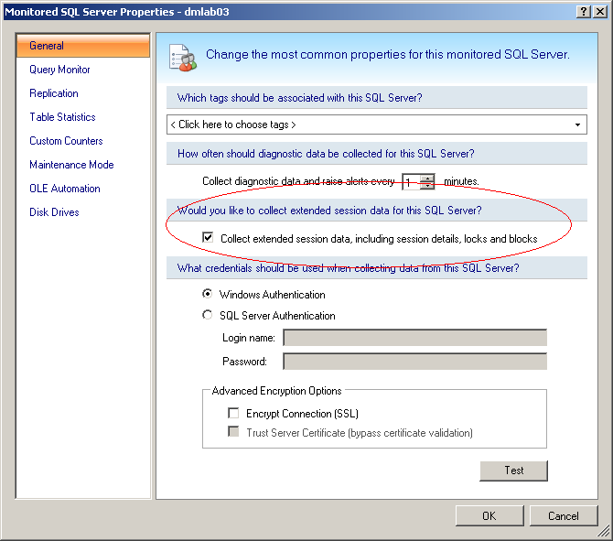

The visible effect of this will be that only the first 500 (configurable) sessions will have Command Text information, unless the text was already collected in another lower-cost fashion such as fn_get_sql or dm_exec_sql_text().

Installation and Upgrade
This feature has no special installation requirements.

Permissions and other Required Configuration
No special considerations.

Licensing Issues
No special considerations.

Dependencies
No special considerations.

Internal Design

Architecture

Collection Service
Upon inspection, the chief cause of excessive logical reads in the Sessions Batch for SQL 2000 is the loop that saves the DBCC INPUTBUFFER output into a temporary table. The most significant performance gains were obtained by removing this temporary table entirely: the command can be output directly into the resultset for consumption by the collection service. The table that follows is from preliminary optimization against a 5000 session server: final numbers may differ.
Description | Reads | Percent improvement
Existing batch | 9510559 | n/a
Existing batch with 500 limiter | 335916 | 96.47%
Optimized batch | 40578 | 99.57%
Optimized batch with 500 limiter | 31037 | 99.67%

This table shows the progressive performance improvements as more sessions are involved. Again, this is based on a preliminary optimization.
 | Number of Sessions
Description | 60 | 500 | 1000 | 5000 | 10000
Existing batch | 8283 | 155245 | 490470 | 9609051 | 24140917
Optimized batch with 500 limiter | 3056 | 6378 | 9430 | 27537 | 52936
Improvement | 63.1% | 95.9% | 98.1% | 99.7% | 99.8%

Improvements to SQL 2005 are not expected to be nearly as effective, nor as necessary, as on SQL 2000. Additional and different optimization techniques may be used during development, possibly including the use of fn_get_sql for SQL 2000 SP3+.
For the purposes of this change the collection service will need to accept the configuration information for the DBCC INPUTBUFFER limiter and the interpreter will likely need to be changed to accommodate the new batch structure. These are not high risk changes.
The sessions will be sorted in the following order before being limited:
- Blocking Count
- Blocked (true/false)
- Wait Time
- Last Activity Time
- Number of Open Transactions
- Memory Usage
- Cumulative CPU
- Cumulative Physical IO

Management Service
No changes anticipated.

Desktop Client
The desktop client will be modified to allow the configuration of the DBCC INPUTBUFFER limiter. By default there will be no limit, but if the limit is enabled by checkbox the default value will be 500.

Repository
The DBCC INPUTBUFFER limiter will be stored in the repository, which will require a schema change and several small stored procedure changes.

Installation Issues
This feature will require an upgrade of the services, desktop client, and repository.

Schedule

Work Breakdown and Sizings

Component | Who | Sizing
Collection Service Changes | Vicky | .5 days
Batch Changes | Vicky | 1 day
Repository Changes | Vicky | .5 days
Desktop Client Changes | Vicky | .5 days
Unit and Integration Testing | Vicky | .5 days
Total |  | 3 days

Areas of Risk
- Customers may be unhappy with the DBCC INPUTBUFFER limiter
- Performance issues may not be adequately addressed
- Performance issues are difficult to replicate and test

Quality Assurance Considerations

Overview
The most significant element of testing for this feature will be the requirement to create environments with a large number of concurrent sessions without, in doing so, over-taxing the test machine so that it creates performance problems not related to SQLdm. As an extreme example, it would probably be better to have 10,000 idle or waitfor sessions than 10,000 active SQL backups. It will also be necessary to have a very stable environment so that the before and after tests are apples-to-apples comparisons.
The numbers used for research purposes in this specification were derived by making a copy of sysprocesses and running the different versions of the batch against that exact copy, such that they should have exactly the same input and output data. This is not going to be feasible in testing. The improvement goals have been set such that they should be reachable in a real-life scenario: the 99% improvements seen here may be observed on a live system, but I would not consider it a failure if the real numbers were closer to 90%.

Developer-Created Unit Tests
None anticipated.

Documentation Considerations
The new DBCC INPUTBUFFER limiter will need to be documented.
The sort order for limited sessions will need to be documented as well.

